23BAI10917
___________________________________________________________________
AIM: To calculate addition of two numbers using python.

Input: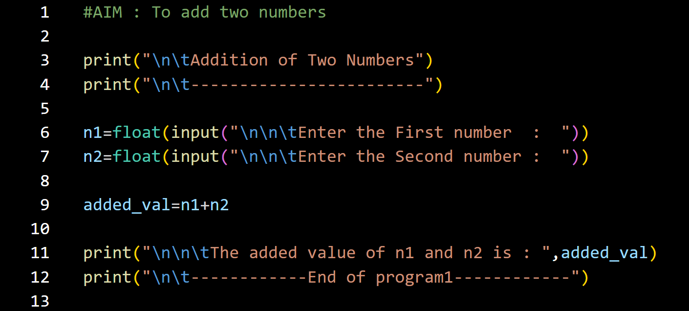Output: 